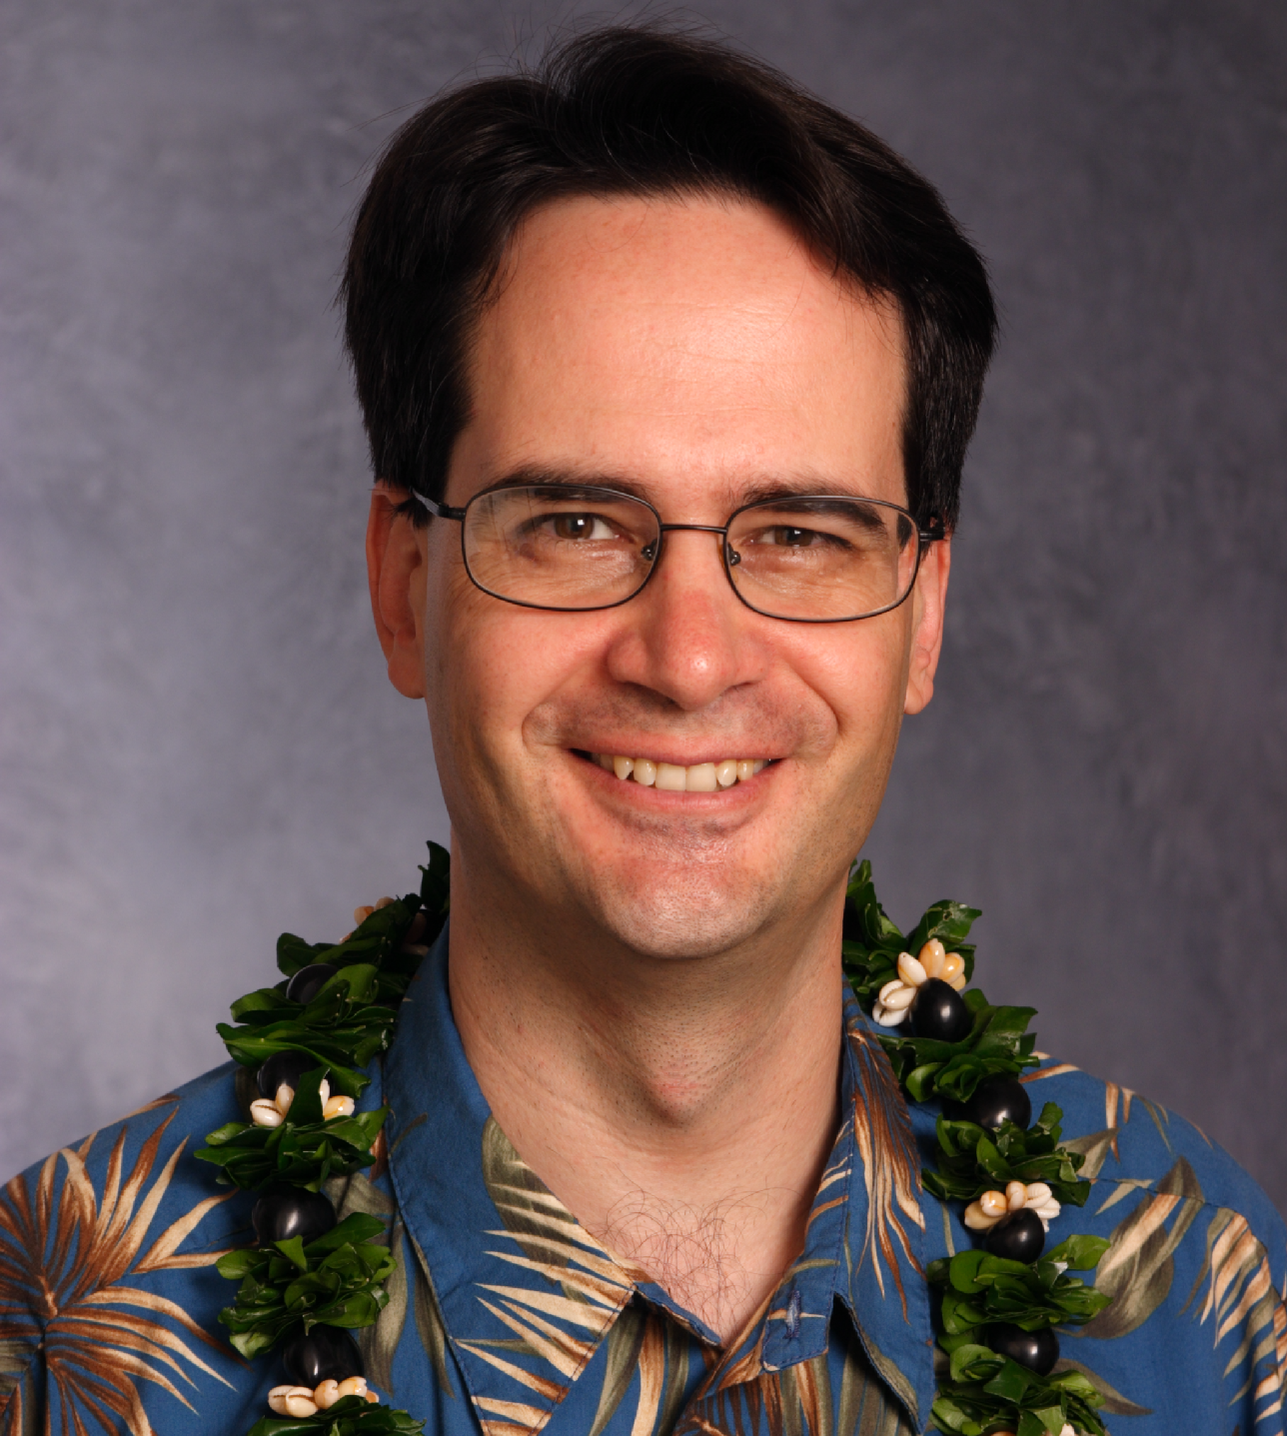

FOR MORE INFORMATION: FOR IMMEDIATE RELEASE
Karl Rhoads, Phone 533-4187, Cell 271-5995, rhoadsk001@hawaii.rr.com January 8, 2006

Karl Rhoads announces run against Harbin

HONOLULU – January 8, 2006 – Karl Rhoads, an attorney and longtime neighborhood board member, announced today that he is running for the State House District 28 seat (Kalihi, Chinatown, Downtown, Sheridan tract). “The residents of District 28 deserve an honest and experienced advocate in the State House of Representatives. I have many years of experience with all levels of government and can hit the ground running in the State House.”

Rhoads and his wife, Cindy, have lived in the district for over nine years and both work in the district as well. In addition to his eight years of service on the Downtown Neighborhood Board, Rhoads has helped fight area crime as an active participant in the Chinatown Citizens Patrol for nine years. Rhoads is the Vice President of his condo association (Honolulu Tower) and is on the Board of Pacific Gateway Center, an organization dedicated to providing economic opportunities to immigrants.

Rhoads has worked in the Legislature for five years for Rep. Marilyn B. Lee. He served as a summer clerk for Intermediate Court of Appeals judge Corinne K.A. Watanabe and worked on Capitol Hill for six years including an internship for Senator John Kerry.

Rhoads graduated with honors from George Washington Law School. He also earned a masters degree in international relations from the University of London, England.
# # #

