REPORT TO THE
STATE OF HAWAII
TWENTY-EIGHT STATE LEGISLATURE
REGULAR SESSION OF 2016
ON
HOUSE CONCURRENT RESOLUTION NO. 29
ADOPTED BY THE
TWENTY-EIGHT STATE LEGISLATURE
REGULAR SESSION OF 2015
SUBMITTED BY THE
DEPARTMENT OF ACCOUNTING AND GENERAL SERVICES

BACKGROUND:
The Hawaii State Legislature, Regular Session of 2015, adopted the attached House Concurrent Resolution No. 29 (H.C.R. 29). This measure requests the Department of Accounting and General Services (DAGS), after consultation with the Department of Transportation (DOT), to determine the cost of placing an overpass over the H-1 freeway to extend between Nuuanu Stream and Queen Emma Street that would reduce traffic noise pollution and be used as a park or other community use purpose.
This measure further requests that DAGS submit a report on its findings and recommendations to the Legislature not later than twenty days prior to the convening of the 2016 Regular Session.
FINDINGS:
"Cap parks", also referred to as highway or deck parks, are built over segments of highways that are below park grade. A 2007 Trust for Public Land study found over 20 cap parks in the United States with at least another dozen or more being planned. The average size is 9 acres covering 1,620 linear feet of highway.
Cap parks are typically beneficial to the areas lacking public park space where residents do not live or work within walking distance (1/4 of a mile) of a park, playground or open space. The lack of recreational space can be linked to obesity related diseases such as asthma and diabetes.
Cap parks are seen as a solution to increase access to rest and recreation space in congested urban areas. However, as with most solutions, many come with both positive and negative implications. On the positive side, capping portions of highways is a way to create large parks in city settings where vacant land is scarce. Residences and businesses are not displaced while reconnecting neighborhoods and communities divided by highways. Cap parks have the potential to generate economic benefits, including enhancing real estate values, attracting businesses and visitors, and creating new jobs.
On the negative side, construction costs are high for cap parks. Operation and maintenance costs will also be significant given their size and amenities. Time for feasibility, environmental, economic and permitting considerations relating to cap parks are lengthy and complicated and must be completed before moving into the design and construction phases.
As vacant land is scarce in downtown Honolulu, H.C.R. 29 seeks to leverage experiences from other cities who have built an elevated deck over their highways to create park and recreational space while also utilizing this newly created space as a physical and cultural bridge to distinct portions of the city. As previously stated, pursuant to H.C.R. 29, DAGS in collaboration with DOT, is requested to study the potential cost of using this freeway capping technique to create an overpass park between Queen Emma Street and Nuuanu stream just outside the downtown Honolulu proper. This proposed location is ideal for the elevated deck capping concept as both the Mauka and Makai lanes of travel on the existing H-1 freeway were built within a man-made trench with the side walls constructed at approximately the same height throughout, thereby creating a natural corridor and an ideal candidate for capping.
The newly created space would bridge the urban core of downtown Honolulu to the South with the more rustic areas of lower Nuuanu to the North. Existing surface transportation routes include bus routes 6 (Pauoa Valley) along Queen Emma street; 55 (Kaneohe/North Shore), 56 (Kailua/Kaneohe), 57 (Kailua-Sealife Park), 57A (Kailua-Keolu Drive), 65 (Kaneohe-Kahaluu) along Pali Highway and route 4 (Nuuanu-Moiliili) along Nuuanu Avenue. The existing Kamamalu Field and Foster Botanical Gardens could blend into the new park expanding existing park use and creating space for a jogging/bike path, green space, a learning environment for outdoor exercise classes and other cultural activities.
Other benefits besides park and recreation space includes reduction of freeway noise for nearby residential units and the addition of new activities to rejuvenate the more rustic area of lower Nuuanu.
A feasibility study could further explore environmental, economic, social and geographic demographic issues and the pros and cons of constructing a cap park over the H-1 Freeway between Queen Emma Street and Nuuanu Stream. Based on Klyde Warren Park’s $1.5M feasibility study of 2004, we estimate it would cost an inflation adjusted amount of $2.1M to perform a feasibility study. Using the Klyde Warren Park’s cost model of $42.3M per acre, the present day cost to construct a cap park between Nuuanu Stream and Queen Emma Street, an area of approximately 20 acres, would be $846M. The ideal size with the proper cost model appears to be about 5-6 acres with an associated price tag of $212M – $254M.
Examples of similar parks:
Park Name | Location | Year Opened | Size (acre) | Tunnel Length (Lf) | Highway | Cost of Construction ($M) | Cost of Operations ($M/year)
Klyde Warren Park | Dallas, TX | 2012 | 5.2 | 1075 approx. | Woodall Rodgers Freeway | 220 | 3
Jim Ellis Freeway Park | Seattle, WA | 1976 | 5.2 | 528 | I-5 | 118 | NA
South River Walk Park | Trenton, NJ | 2004 | 6.5 | 898 | US 29 | 150 | NA
Hance Park | Phoenix, AZ | 1992 | 10 | 2640 | I-10 | 105 | NA
Rose Kennedy Greenway | Boston, MA | 2008 | 15 | 5280 | I-93 | NA | NA

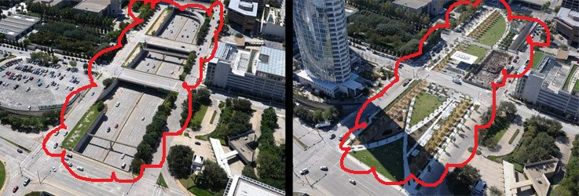
Klyde Warren Park, Dallas, Texas, built over Woodall Rodgers Freeway. The urban green space connects the city’s Arts District and downtown includes a dog park, children’s play area, running trails, and a performance pavilion with daily free programming. Opened October 2012.

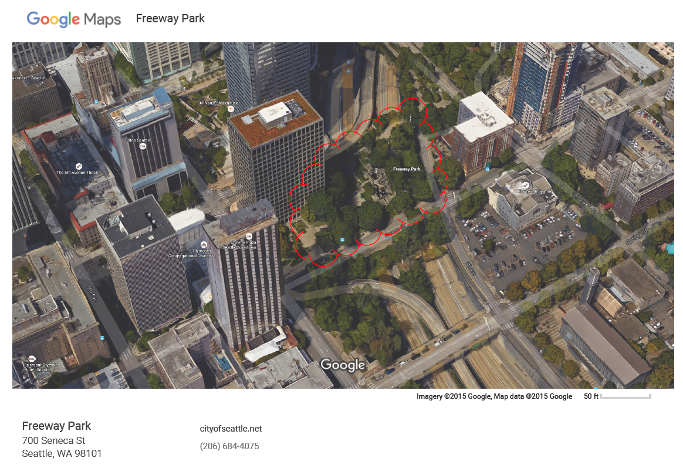
Jim Ellis Freeway Park, Seattle, Washington, consists of elevated deck park bridges over the Interstate 5 Freeway adjoining the Washington State Convention and Trade Center to First Hill. The park provides a space where residents, shoppers, downtown office workers, hotel visitors and citizens of Seattle may come together to enjoy the social elements of a city park. It is noted that because of the relatively small size of the park (5.2 acres), users are subject to the white noise of the freeway.
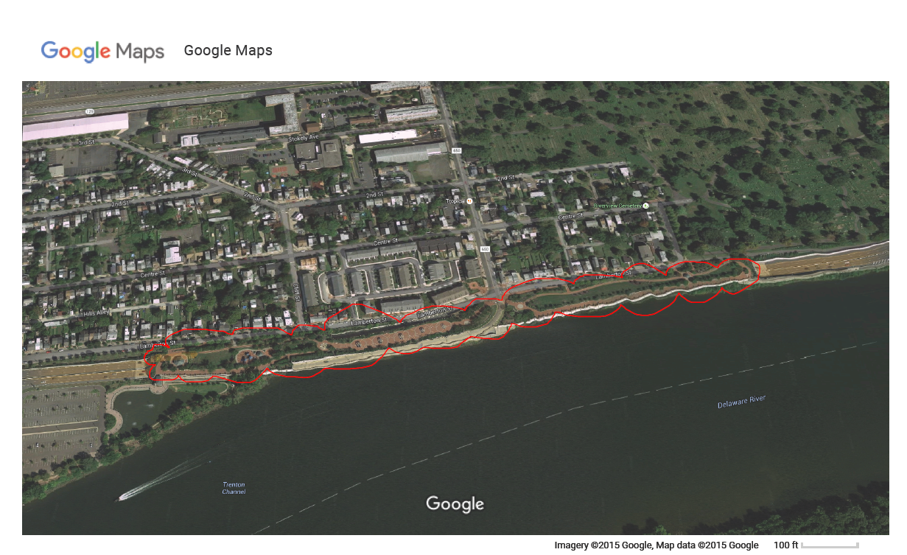
South River Walk Park is located above the Route 29 tunnel and was gifted to the Mercer County Park Commission in 2004 by the State of New Jersey. The 6.5 acre park focuses on the history of Trenton and its connection to the Delaware River. The park has hosted many festivals and art fairs as well as weddings, walk-athons and family events.

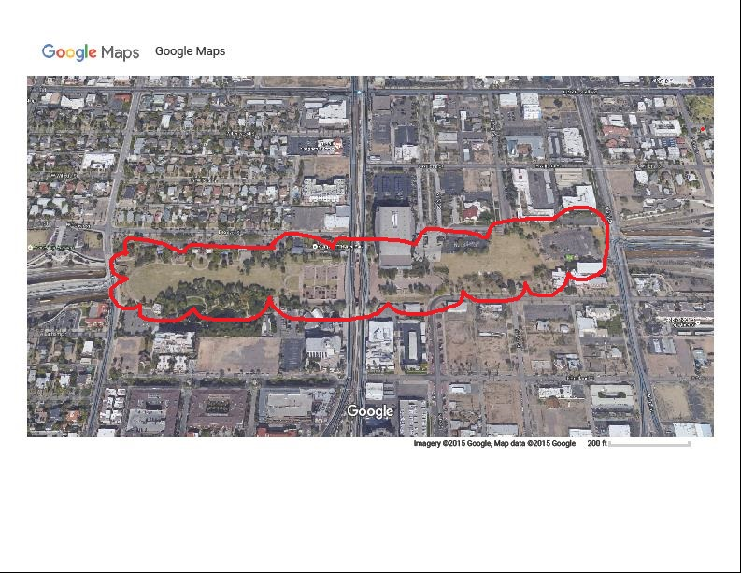
Margaret T. Hance Park is a 10 acre park near downtown Phoenix, Arizona. It lies on top of a half-mile stretch of the ten-lane Papago Freeway, a portion of the Interstate 10.
Specific plans for a park began in 1983, when solutions were proposed for improving surrounding neighborhoods that had been affected by freeway construction 20 years earlier. The park was completed and opened in April 1992. It features a wide variety of outdoor facilities, interpretive infrastructure and areas for public recreation. The park is owned and operated by the city of Phoenix while the Hance Park Conservancy handles annual funding for events and park improvements.
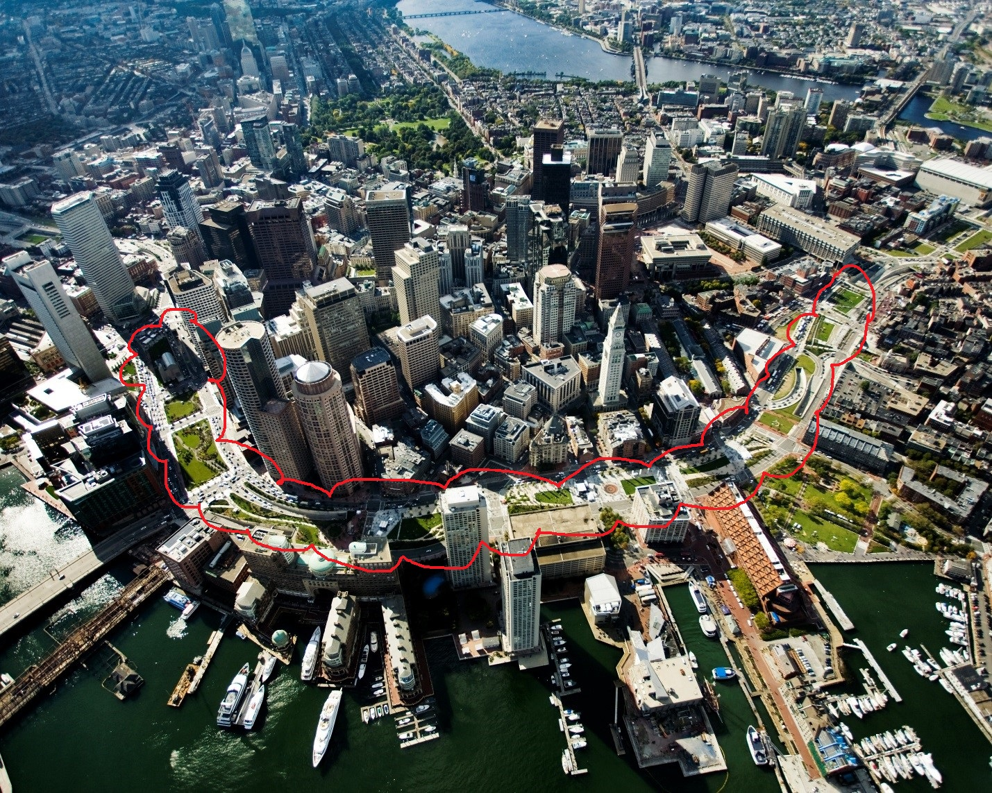
The Rose Fitzgerald Kennedy Greenway is a linear urban park located in several downtown neighborhoods of Boston, Massachusetts. It consists of landscaped gardens, promenades, plazas, fountains, art, and specialty lighting systems that stretch over one mile through Chinatown, the North End, the Financial District, and Harbor communities. Officially opened in October 2008, the 15 acre Greenway sits on land created from demolition of the John F. Kennedy Expressway under the Big Dig.

